RESOLUTION NO.__________

RE: CERTIFICATE OF APPROPRIATENESS UNDER THE
PROVISIONS OF THE ACT OF THE PENNSYLVANIA
LEGISLATURE 1961, JUNE 13, P.L. 282 (53
SECTION 8004) AND BETHLEHEM ORDINANCE NO.
3952 AS AMENDED.

The applicant proposes to install window signs and a blade sign at 553 Main St.

NOW, THEREFORE, BE IT RESOLVED by the Council of the City of Bethlehem that a Certificate of Appropriateness is hereby granted for the proposal.

Sponsored by: (s)

(s)

ADOPTED BY COUNCIL THIS DAY OF

(s)
President of Council

ATTEST:

(s)
City Clerk

HISTORICAL & ARCHITECTURAL REVIEW BOARD

The applicant proposes to install window signs and a blade sign at
553 Main St.

APPLICATION #2:

Rubel St. II LP
559 Main St.
Bethlehem, PA 18018

OWNER:

__________________________________________________________________________

The Board upon motion by Marsha Fritz and seconded by Connie Postupack adopted the proposal that City Council issue a Certificate of Appropriateness for the following:

- The hanging sign will be 24” x 16”h double sided and should have a pin stripe
around the perimeter of the sign approx. ¼” wide, ¾” from the edges.

2. The letter at the bottom of the sign should be changed to Serif style letters.

3. Bracket to be mounted in mortar joints

4. The motion was unanimously approved.

__________________________________________________________________________

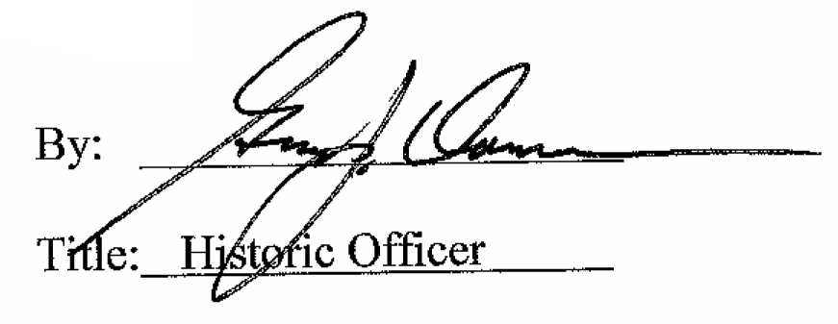

Date of Meeting: July 11, 2018

